

Company Profile

Cell: +254728522599, +254728074922, +254722734516

2ND Floor, Kilimambogo House, Mfangano Street Opp. Easy Coach Bus Station.

Email:info@traceafricasmart.com Web: www.traceafricasmart.com

“………Unlocking the future today……...”

TRACE AFRICA SMART LIMITED.

Tagline: Unlocking the future today.

WHO WE ARE.

TASL is a Robust and dynamic consultancy firm operating in Kenya. With an array of a well-trained and informed team, TASL has mastered the art of combining talent, teamwork, and experience and acquired knowledge pertinent to providing solutions to our clients’ needs.

We proclaim in-depth understanding of the rapidly changing business environment and the need for organizations, be it Governmental, Private Businesses or Non-Governmental to tailor their operations, structures, cultures, policies, goals and activities to suit the desires of their clients.

In recognition of the fact that clients constitute any organization’s lifeline, TASL is committed to serving them diligently and with utmost efficiency.

Concurrently TASL has overly ensured that our core values of Integrity, Passion, Teamwork Leadership and Commitment to Change, Results and Recognition, become the foundation upon which our services are rendered. This is aimed at helping our clients make improvements to their operations, performance and cultures thereby fostering the realization of their set goals and equipping them with the required skills and techniques to meet their customers’ needs.

At TASL we unlock the future “today”, and ensure that professionals acquire leadership skills of exceptionally high quality, necessary to thrive in a business environment whose dynamism is increasing incessantly.
TASL’s Vision:

To be Africa’s first choice service provider for organizations development, skills and business consultancy solutions.
TASL’s Mission:

We are committed to provide the best consultancy solutions through smart and superior, professional and quality development skills to both organizations and individuals.

Our Belief: We believe in the power of teamwork, commitment and consistency in unlocking the full potential of individuals and organizations in the environment in which they operate.

Our core values:

Integrity:
TASL values honesty, consistency, Respect accountability and keeping our promises/word.

Passion:

TASL values, the passion will to work and offer the best to our clients, being the best at what we do and do our work with passion thereby making our job fun and educative as well.

Teamwork:
TASL values team work as a tool to enable the firm attain all its desired goals as well as the client’s.

Leadership: We value the growth and development of individuals through our programs to promote individuals who can make sound decisions, who are enthusiastic and committed to personal organizations development.

Commitment to Change:
We value the need to break free from yester believes and adopt tomorrow’s ideologies

Results: We value results as a show for the effort put in what we do as a firm.

Recognition: We value and also recognize performance.

WHAT WE DO.

TASL endeavors to be the key to unlocking the doors to success for individuals, organizations and business in the fast changing business environment through:

- Corporate Trainings.

- Events Management.

- Organized Getaways.

- Team buildings and Safaris.

TRAINING PROGRAMS.

At TASL our objectives are met through:

- Digital strategies and capacity building training programs.

- Financial management training programs.

- Culture change/Transformation programs.

- Leadership management and planning trainings for successful business programs.

- Performance Improvement Analytics training programs.

- Productivity improvement planning Approaches.

- Organizational development training programs.

- Customer Service and public relations training programs.

- Organized business networking programs.

- Youth’s empowerment trainings/motivation speaking and talent identification and skill development.

EVENTS MANAGEMENT TEAMBUILDINGS AND SAFARIS.

- Team buildings.

  - At TASL we use teambuilding sessions to articulate the practical work environment through conference training as well as outdoor activities which are professionally crafted to offer a learning platform for organizations and businesses staff.

- Organizations end year/annual meetings parties.

  - Such are organized as per the client’s requirements and specifications. We take into

  - Account the details and instructions provide in reference to providing the best services.

- Weddings packages and planning.

  - TASL offers wedding planning and packages that are tailored to suit our client’s budget

- Organized Getaways.

  - TASL through TAS organize for family, organizations, group getaways to various luxurious hotels and holiday destination sites in Kenya.

- Organized Educational Trips/Study Tours.

  - We at TASL through TAS organize educational trips and study tours for schools and institutions of higher learning with an aim of integrating practical representation of learnt information for students.

- Organizations estates parties/ birth day parties/Re-unions/Graduation parties/school

- Leavers’ parties.

  - We organize parties to rekindle old memories as far as yester years and special days in people’s lives. This we carry at a friendly cost and provide the best service and engagements.

- Organized talks.

  - We at TASL organize talks ranging from Business, inspirational, youth empowerment and motivational talks.
Our Leadership team

Our leadership team is headed by young vibrant individuals with several years of experience who are agile at all times keen to identify the best ideas for the industries and ready to implement these ideas at all levels in ensuring TASL offers the best.

Mr. Vincent Nyamora Osere – CEO / Managing Director

The CEO/MD of Trace Africa Smart Limited is a former Banker who has worked at different levels in the Banking sector, as an Operations Officer, Bank Teller, Customer Service Officer, Personal Banking Officer, Credit Officer and a Credit Administration Supervisor. Mr. VINCENT boosts experience in the field of Management, leadership and training.

Mr. VINCENT a former student leader of JKUAT holds a degree in Business Information technology, from the institution and is currently pursuing a MBA degree in–Financial Management at ST. Paul’s University as well as CPA accreditation.

He is the founder and Chairman of International Piles Eradication Foundation, he is a director at Simba County link Transport Company and is a founder of the Baba Studio and Film school. He is a motivational speaker and counseling director the business leadership management trainer and a team builder at TASL.

“We at Trace provide a perfect base for individuals, corporate and other organizations to develop a sense of believe in what they stand for and make their worlds a better place thus supporting their endeavors”

MS. Moureen Nyambura Njuguna - Director Planning and Logistics

Ms. Njuguna is Graduate of Kampala International University and holds a computer science degree with specialization in Management Information System. She also holds a diploma in IT and IMIS from Kenya School of Professional Studies.

She is a former banker with experience in customer service and debt management and also is a former supervisor of Kencall EPZ.

Ms. Njuguna boosts several years of experience in management and is at Trace Africa Smart Limited the -planning and logistics Director.

She is also a life coach in matters finance and money management as well as a full time mentor and financial advisor.

“We tap and harness individual strengths thereby creating independent smart individuals and Organizations ready to face tomorrow”.

Mr. Robert Gatimu Mugo - Lead Trainer and Psychologist / Head Team Builder

Mr. Robert is a graduate of the University of Nairobi (BA. Psychology Option) and is accredited by the Kenya Counseling and Psychological Association. Robert has worked as a project officer at Beacon of Hope Center, Nairobi. Notably he has had the opportunity to work with leading organizations in Kenya such as: Sketchers design Ltd, Ministry of Devolution and Planning/Huduma Kenya, The county Government of Machakos Ministry of Health and the Ministry of Education, the National Oil Corporation Kenya, The Independent Medico-Legal Unit and The World Health Organization.

He is at TASL, the lead trainer, life coach, inspirational speaker and team builder.

“Believe and trust, teamwork and determination are the foundations we trust in and these we share through our professional trainings to develop attitudes and character change”

Mr. Francis Munene Wambugu - Head Of Communication Department

Mr. Wambugu is a graduate of Jomo Kenyatta University of Agriculture and technology; He holds a degree in Business information technology and is currently TASL’s communications team leader.

Wambugu has in depth understanding of communication techniques and is fondly involved in the implementation of the newest technologies at TASL, Thus enabling the institution remain abreast with new technological techniques.

He is skilled in online marketing, advertisement, networking and communications techniques at large. Previously Mr. Wambugu has worked for Kenyatta University Cisco Network Academy, Old Mutual life insurance Company ltd, Kenya civil aviation authority, Purikanji agencies, Computer overseas college as well as Vifra Solutions agency.

“We listen to our clients, analyze the needs and ensure each need is satisfied as customer is Key and better still our lifeline at TASL”

Mr. Geoffrey Ndege Osere - Head Of Events Management Department

Mr. Osere is professional dance choreographer who has worked with several Gospel artists in Kenya; he is a graduate of Daystar University with a Bachelor of Arts in communication and holds a diploma in communication from Multi-Media University.

Osere heads entertainment department at TASL and is a member of the events management team at TASL.

He heads the All Starz Dance Crew, a dance group that is natured under TASL.

Osere is skilled in videography, photography and plays key role within the safaris and events management team in ensuring that TASL remains true to its values of offering and delivering on its promises.

“Our intention is to keep you entertained and always uplifted by what we offer at TASL. At TASL we keep our word.”

Mrs. Dorothy Anyona - Head Of Customer Service Department

Dorothy is an ATC and CPA finalist with a over ten years experience in accounting, she is well informed in the field of accountancy and is currently involved in the mentorship of individuals on customer service delivery. Dorothy head the customer service team and is a vibrant team player. Notably Dorothy has worked for various institutions such as, Geoner System Ltd, Owala and Associates, Kenya Institute of Organic Farming, Kenya Institute of Education, Leather Works and Safety Products and Pakow Enterprises.

“Quality serve to all our clients, is at the Heart of TASL and we always ready to measure up to the needs of each client all the time”

Our Clientele

- IQ CONSULTANCY.

- SPORTS KENYA.

- FAMILY BANK LIMITED.

- CRYSTAL ELSIE LIMITED.

- SIMBA COUNTY LINK LIMITED.

- GUTON KENYA ENTERPRISES LIMITED.
GALLERY

GETAWAY PICS: OLOLOSOKUAN.
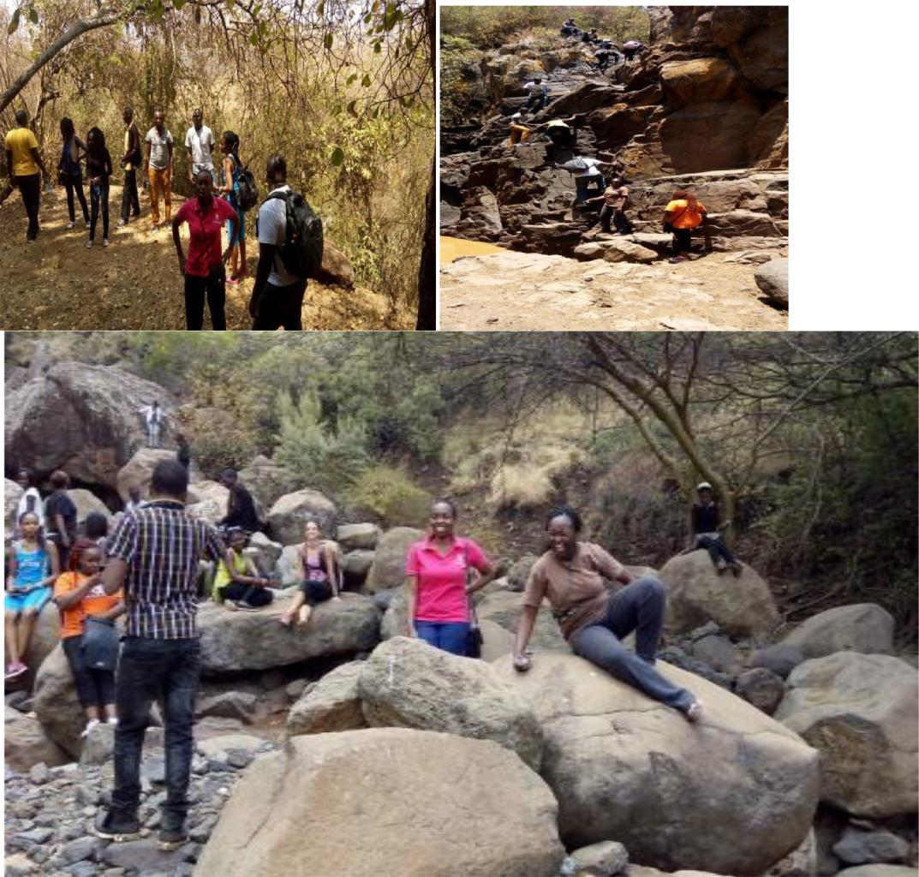

HOTELS FACILITIES.
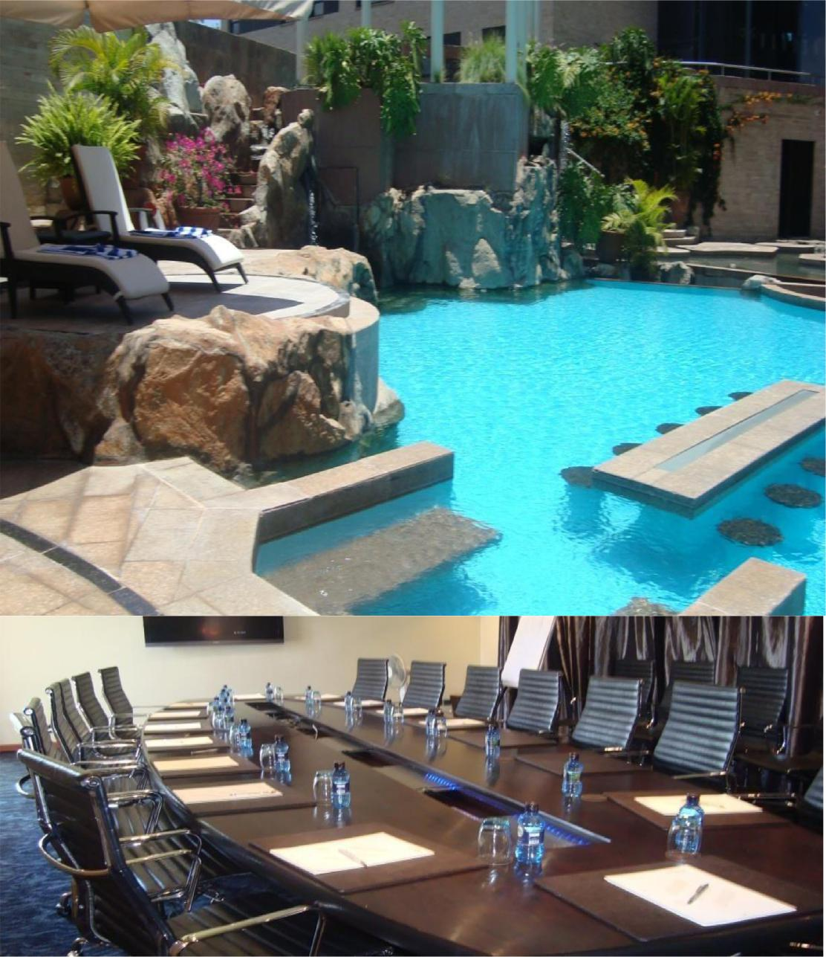
CORPORATE TRAINING.
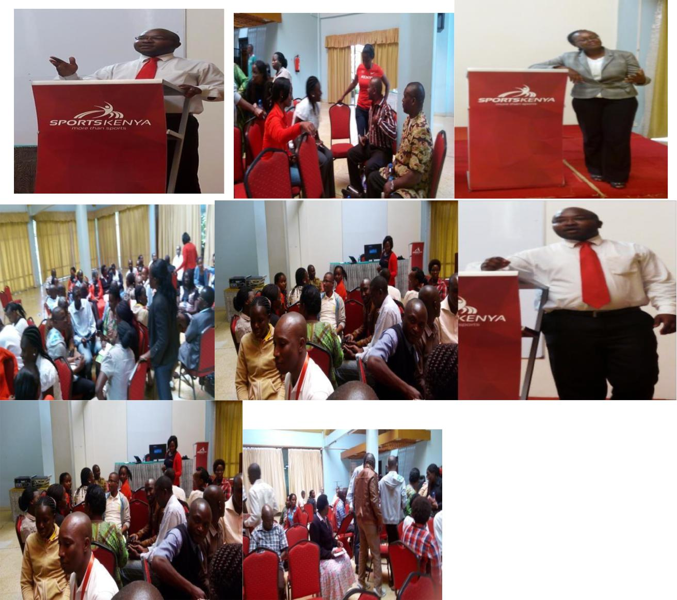

TEAM BUILDINGS.
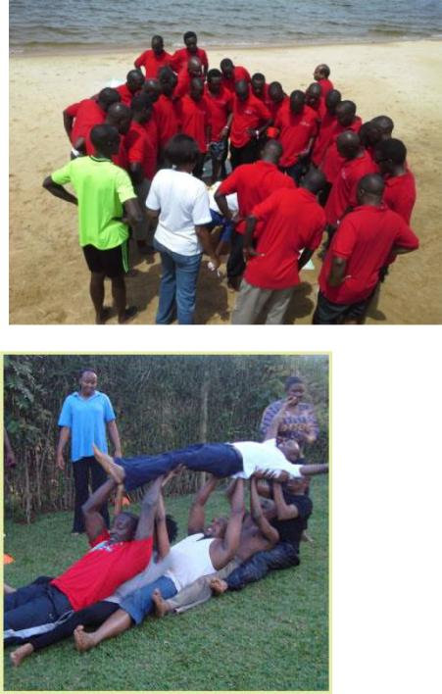
TRANSPORT: PICS-VANS/BUSES


TEAM ALLSTARZ DANCE GROUP.


WEDDINGS.
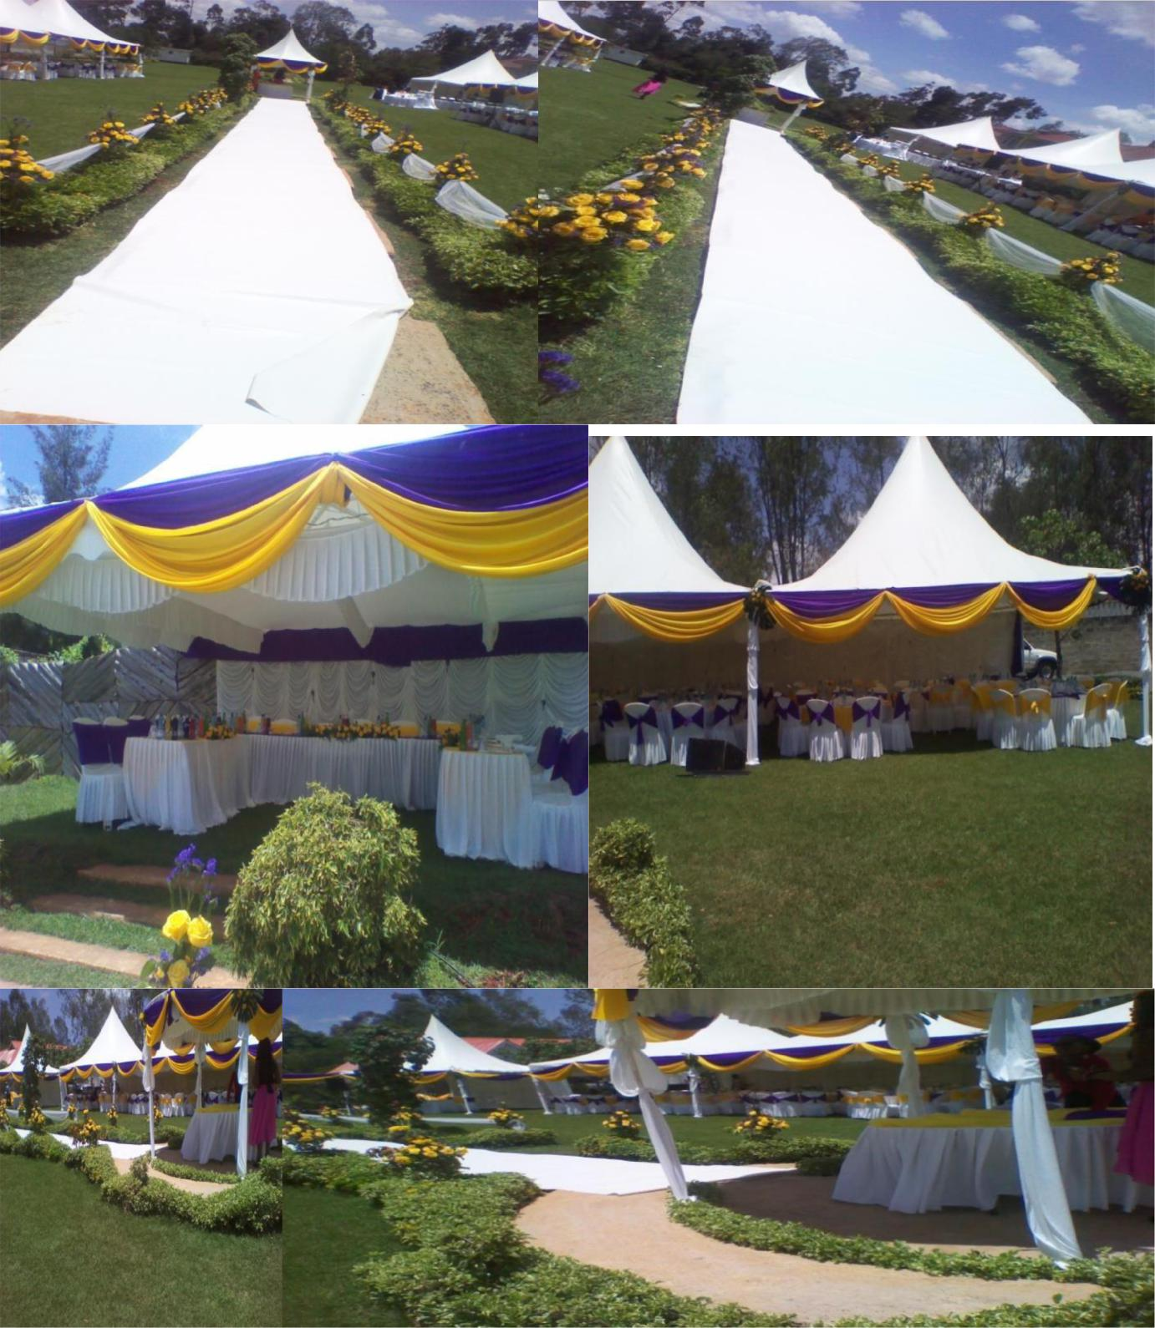

COMMENDATION LETTERS.
